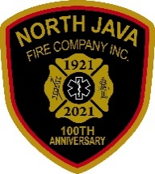 North Java Fire Co., Inc.

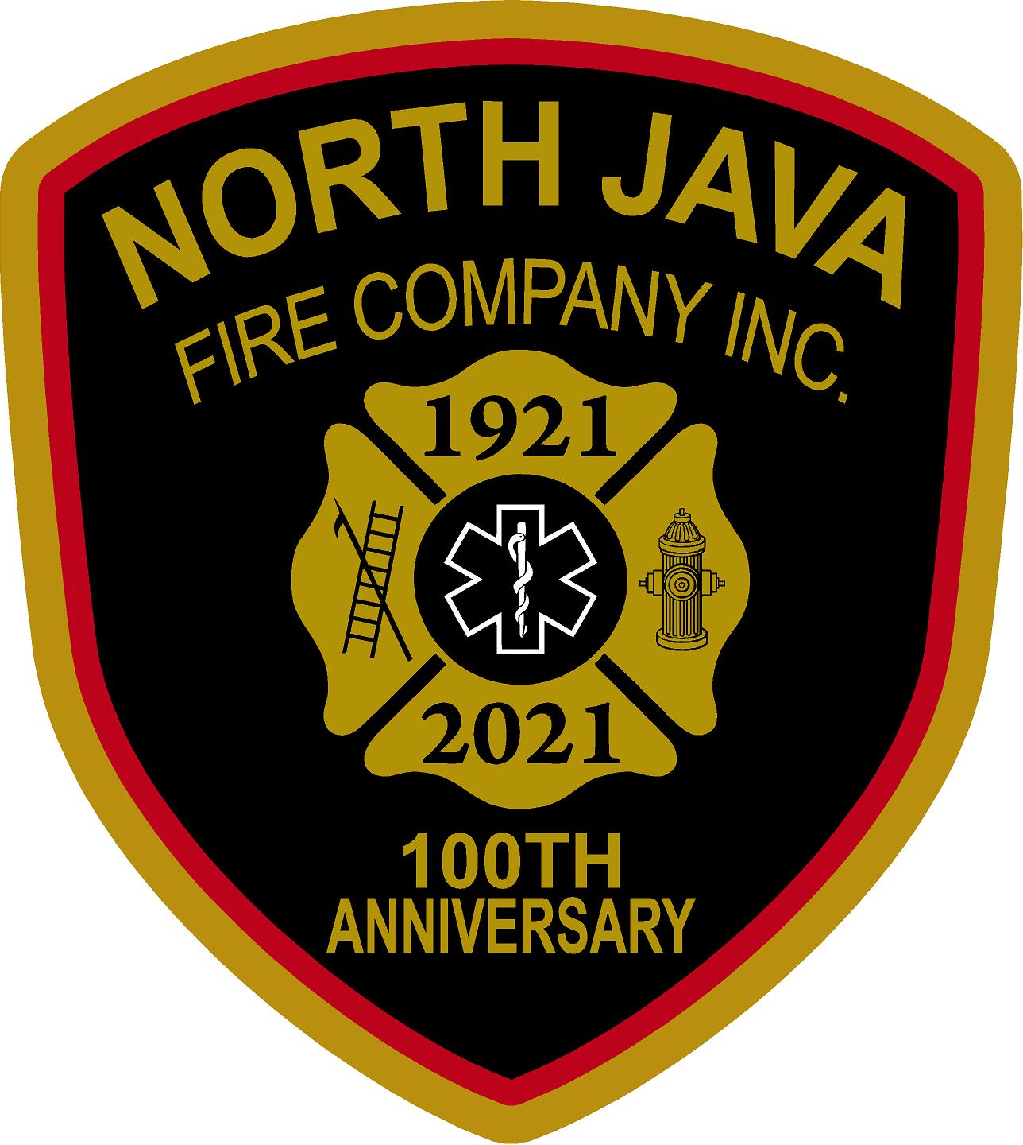

PO Box 137

North Java, NY 14113

[www.northjavafd.com](http://www.northjavafd.com)

**Hall Rental Contract**

**Please initial that you understand each section of the contract:**

Initial ______ Contract made for the day of ______________________, 20____, between North Java Fire Co., Inc., hereinafter referred to as we or us; and _____________________________, hereinafter referred to as the lessee or you.

Initial ______ We hereby lease to lessee, and lessee herby does lease from us, the North Java Fire Co. hall and/or engine room from the hours of _______ AM / PM until _______ AM / PM.

Initial ______ You agree to surrender the premises no later than two o’clock am (2:00am) in good condition as it were at the commencement of the term; reasonable wear and tear accepted.

Initial ______ Lease includes the use of the furniture, heating, A/C, and lighting. Lease shall **NOT** include the water, pop, beer, or any beverages in the refrigerators.

Initial ______ Lessee agrees to pay:

Rental Deposit

$ $ ____ For the use of the main hall to include security deposit.

$ $ ____ For the use of the engine room to include security deposit.

(Can ONLY rent Engine Room from March 1st through Nov 15th)

Total $

Initial ______ The security deposit must be paid in full at the time of submitting the signed agreement to hold the date requested for rental. $ _ paid on _______/____/20____

Initial ______ Full payment must be received within 30 days of the date requested for rental.

Initial ______ If you are a non-for-profit organization, governmental proof of status must be provided.

Initial ______ The security deposit will be returned to the lessee **ONLY** if there is no damage to the building or its contents, nothing is missing from the building, and it is returned in the condition it was rented in.

The security deposit will **NOT** be returned if any of the rules in the entirety of this agreement are broken (ie. cleaning, decorations, kitchen use, etc.). The return of the deposit will be at the discretion of the current Building Superintendent.

Initial ______ If cancellation of your event is necessary for any reason, the North Java Fire Co., Inc., will retain $50.00 from any money paid.

Initial ______ If for any reason the check(s) submitted for payment for **any part** of the rental is returned, the contract will be void and the rental date will be opened to others if needed, unless full rental cost and check fee is paid in cash within one week of rental date or other arrangements are made.

Initial ______ ALCOHOL: You must carry liability insurance including dram shop insurance in the sum of $1 million, at your expense, if alcoholic beverages will be served by bartenders or servers. Liability insurance will insure both lessee and the North Java Fire Co., Inc. against claims resulting from the use of the premises.

If you are **NOT** planning on having alcoholic beverages served, please sign here:

______________________________________________.

Initial ______ KITCHEN USE: We shall supply limited use of the kitchen, refrigerators, and other supplies limited to what we have, if desired. The kitchen and everything in it **MUST** be clean before you or the caterer leaves. You may use kitchen facilities to warm and keep food warm that you have previously prepared. We do **NOT** provide dish towels or garbage bags. The use of the kitchen is **NOT** included when only the engine room is rented.

Initial ______ DECORATIONS: Do **NOT** apply tape to the white painted walls. Do **NOT** use tacks, push pins, or nails of any size when decorating. Balloons shall be secured, so they do not float up into the ceiling fans. Plastic hooks have been placed on the ceiling for you to use for hanging decorations. However, you may **NOT** move the hooks from where they have been placed. Do **NOT** cover any of the plaque boards and do NOT use tape on the glass of the trophy case. No staging of any kind will be allowed.

Initial ______ CLEANING: You shall clean the premises on the same day/night the event takes place. Cleaning consists of the following: picking up of all tables and chairs (engine room only), sweeping all floors, damp mopping any spills, and taking **ALL** garbage (including bathroom garbage’s) out to the dumpster. Please do **NOT** leave any boxes or garbage bags on the ground next to the dumpster. Boxes may be left in the engine room.

You must wash and put away any dishes/utensils, beer pitchers, and coffee pots. All decorations must be removed.

Initial ______ You shall save harmless and indemnify us against all expense, lawsuit, claims, and judgments resulting from your use of the premises.

Initial ______ You agree not to engage in or permit any unlawful business on the premises, **including underage drinking of alcoholic beverages.**

________________________________________ _____________________________________________

Lessee’s Printed Name Lessee’s Signature Date

________________________________________ _____________________________________________

Lessee’s Address Lessee’s Phone Number

_________________________________________________

Building Superintendent Signature Date

**Hall Rental Fee Schedule**

|  |  |  |  |  |  |
| --- | --- | --- | --- | --- | --- |
|  | **Main Hall** | **Security**  **Deposit** | **Engine Room** | **Security**  **Deposit** | **Comments** |
| General Public | $500 | $100 | $100 | $100 |  |
| Non-for-Profit | $250 | $100 | $100 | $100 | Must provide proof of non-for-profit status. |
| Firemen/Members | $100 | $100 | $50 | $100 | Firemen may rent the hall at the firemen’s rate if the event is for an immediate family member – parents, spouse, and/or children. The fireman renting is responsible for clean up and managing the event. |
| Funerals | No charge |  | No charge |  |  |

* Engine room will **NOT** be rented out during the time period of November 15th – March 1st of each year.

** If only the engine room is rented, there is **NO** use of the kitchen.

November 2022

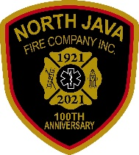 North Java Fire Co., Inc.



PO Box 137

North Java, NY 14113

[www.northjavafd.com](http://www.northjavafd.com)

**Caterer’s Contract**

**Please initial that you understand each section of the contract:**

Initial ______ Contract made for the day of __________________________, 20____, between the North Java Fire Co., Inc. and the caterer hired by individuals for event.

This contract must be signed and returned by __________________________, 20____.

The hall will be unlocked by 8:00 am on the day of the event being held.

Initial ______ The North Java Fire Co., Inc. shall supply main appliances (ie. refrigerators and ovens) and other supplies limited to what we have. All supplies, with the exception of the refrigerators, must be signed out and back in with the current Building Superintendent.

The Fire Co., does **NOT** supply garbage bags or dish towels.

Initial ______ All garbage must be placed inside the dumpster. Please do **NOT** leave any boxes or garbage bags on the ground next to the dumpster. Boxes may be left in the engine room.

Initial ______ The kitchen MUST be cleaned before you leave. Failure to follow this contract will result in lessee’s loss of security deposit.

Please return completed contract to:

North Java Fire Co., Inc.

Attn: Building Superintendent

PO Box 137

North Java, NY 14113

________________________________________ _____________________________________________

Caterer’s Printed Name Caterer’s Signature Date

________________________________________

Caterer’s Phone Number